# Intro to Visual Studio 2015

# Creating a Visual Studio Project

This document is a step by step guide for creating a C++ project in Visual Studio 2015. The steps are listed below along with the screenshots:

* Open Visual Studio 2015. You should be presented with this screen.

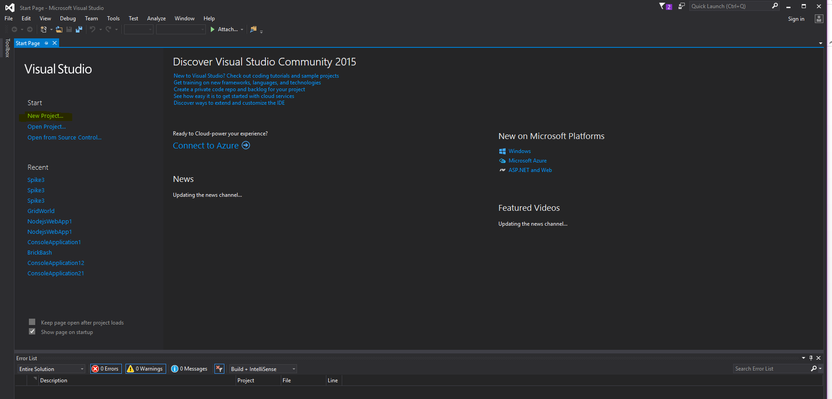

* Click on the New Project and you will be taken to the next screen displayed below.
* Choose Visual C++ from the options on the left side. Then Choose Win32 Console Application.
* Type in the Name for the Project and choose the location where you want to save the project.
* After you have set up everything, click on ‘OK’ button.

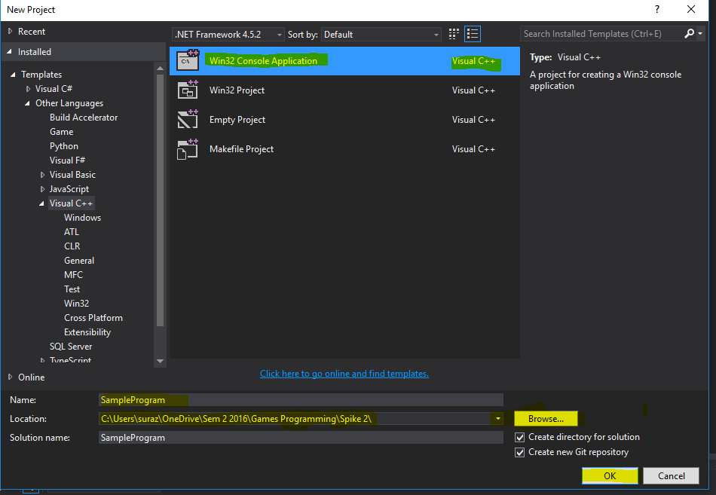

* You will be presented with the following screen.
* Click on Next

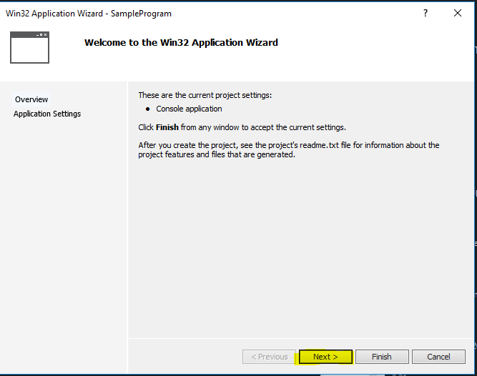

* Finally, when presented the screen shown below, click on Finish.

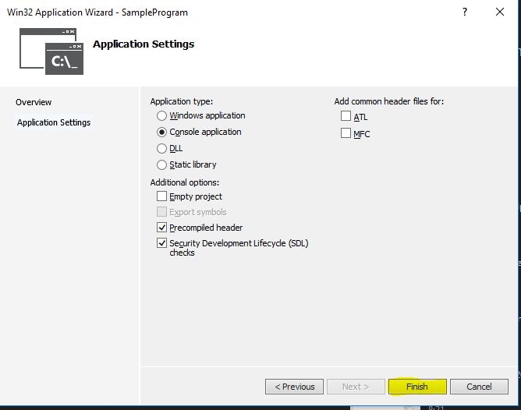

* After the previous step, you will be presented with an empty project. On the right hand side you can find solution explorer which displays the file structures. You can find your headers and source files here.

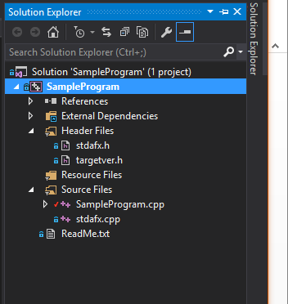

* After the above step, you are good to start coding. Write a basic program in the cpp file.

# Debugging using Breakpoints

Once you have a basic program, you can use the breakpoints as a debugging tool. You can create multiple breakpoints. The program will stop execution at these breakpoints. To create the breakpoint, follow the steps listed below:

* Click on the left of the line number where you would like to create a breakpoint. A red circle should appear as shown below.

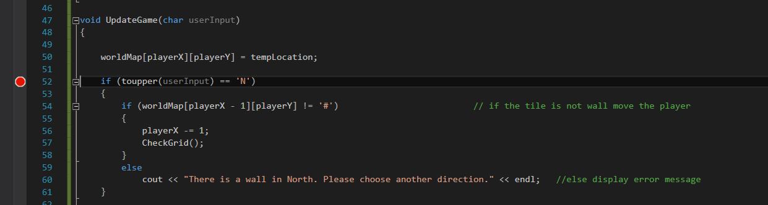

* Run the program in the Local Window Debugger
* Once the code reaches the breakpoint it stops and you can see the arrow sign on the red circle.

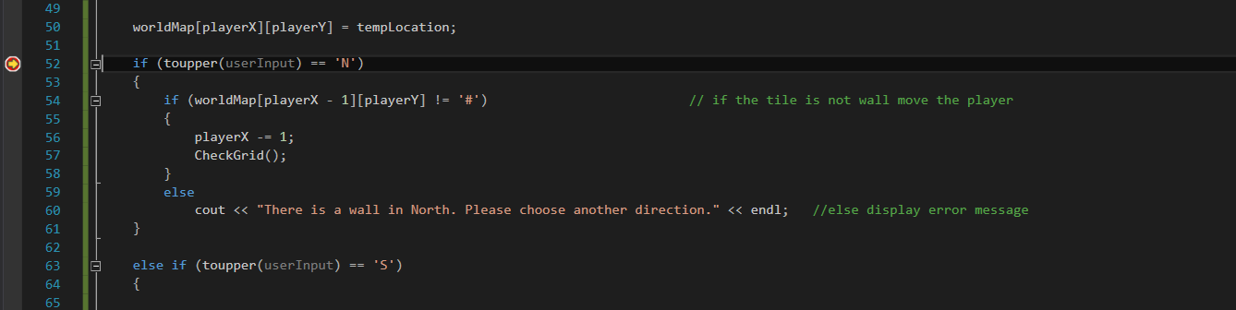

* You can inspect the value of the variable simply by hovering above the variable name.

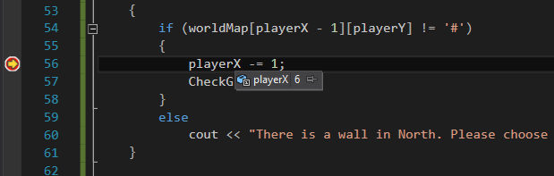

* To remove the breakpoint, click on the red circle again.